 | Rubber encapsulated diamond wire  - Our wire beads are processed through HIP technology  - Wire is encapsulated with rubber for a robust assembly  - Wires have been proven for fast cutting  - Strong inner wire for high performance service life  - Wires are assembled with our without spring spacers
  stone – diamond WIRE
  diamond wire - granite
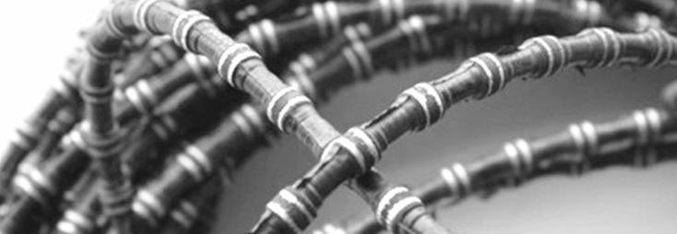

Dee Tec manufactures diamond tools for various construction & stone applications using an advanced Hot Isostatic Pressing technology which allows the tools to perform in demanding conditions on a consistent basis.

