stone – diamond blades

granite – marble blades

stone – diamond blades
- Our segments are similar to the ProHybrid Series
- All segments are welded onto the steel core
- Hybrid – DP – Diamond placement system
- Custom blades / silent blades can be made to spec
- Blades are designed for free cutting

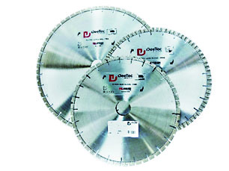

Dee Tec manufactures diamond tools for various construction & stone applications using an advanced Hot Isostatic Pressing technology which allows the tools to perform in demanding conditions on a consistent basis.

